

Department | FED
Subject | DSA-2
Academic Year | Ⅰ-Ⅲ Semester(2025-26)
Faculty Name | Ms. Alluri Swathi
Student Name | Anumola Jhansi Priya
Roll Number | 2520090205
Branch | CSIT
Course Outcome | 3
Case Study Topic:SecureVote – Digital Voting & Election Analytics System using BFS

Work Done Summary:
Implemented Breadth First Search (BFS) in Java for election monitoring and voter network traversal. Modeled voters, polling stations, and election activities as graph nodes connected through edges. BFS traversal was used to monitor voting activities level by level and detect suspicious voting patterns. Implemented voter registration, authentication verification, ballot casting, vote counting, election analytics, and fraud detection using graph traversal techniques. Demonstrated BFS traversal for auditing connected voting records and analyzing election flow efficiently. Compared BFS traversal with DFS – BFS is more suitable for level-wise monitoring and shortest-path based election analysis.

Implementation Details :
- Created Graph class using adjacency list representation.
- addEdge() connects voter nodes and polling stations.
- BFS(startNode) uses Queue data structure for traversal.
- Visited array prevents duplicate traversal of nodes.
- BFS traversal monitors election activities level by level.
- Fraud detection performed by identifying suspicious repeated connections.
- Main method created voter graph and demonstrated BFS traversal.

BFS ensures efficient election auditing and monitoring operations.

Result : Screenshots/Output
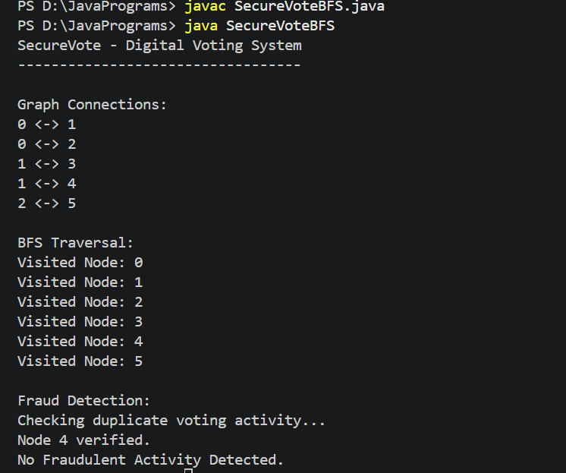

Time Complexity:
• BFS Traversal: O(V + E)
• Graph Construction: O(E)
• BFS is efficient for connected voter network analysis and election monitoring systems.

GitHub Link :

Student Signature | Faculty Signature

